Advanced Java EPITA

USER GUIDE

Advanced Java: **Quiz Application**

**Balepu Ushasri**

**Ushasri**

Advanced Java EPITA

1. This project is a brief overview of a Quiz application developed in Spring 3 MVC framework of java. To develop this application, we incorporated the Spring 3 MVC with Hibernate 3.
2. Welcome Page for Quiz Application.

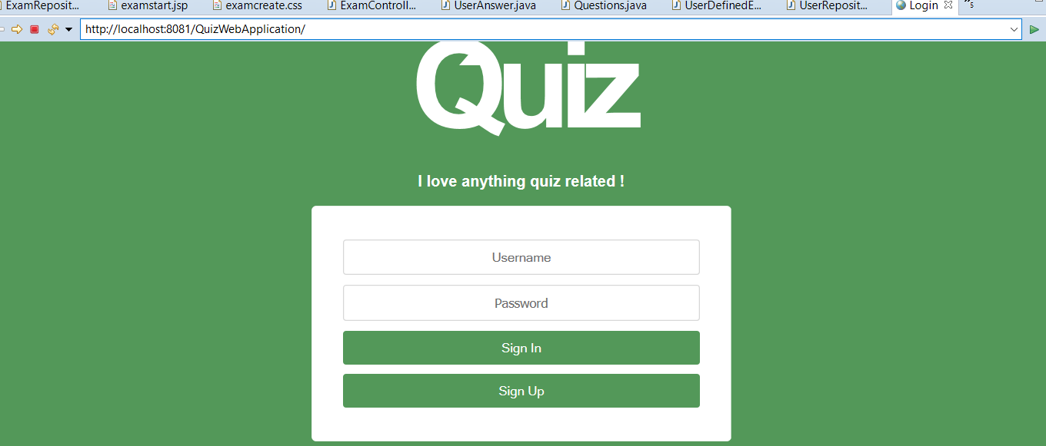

1. Registration for user to login.

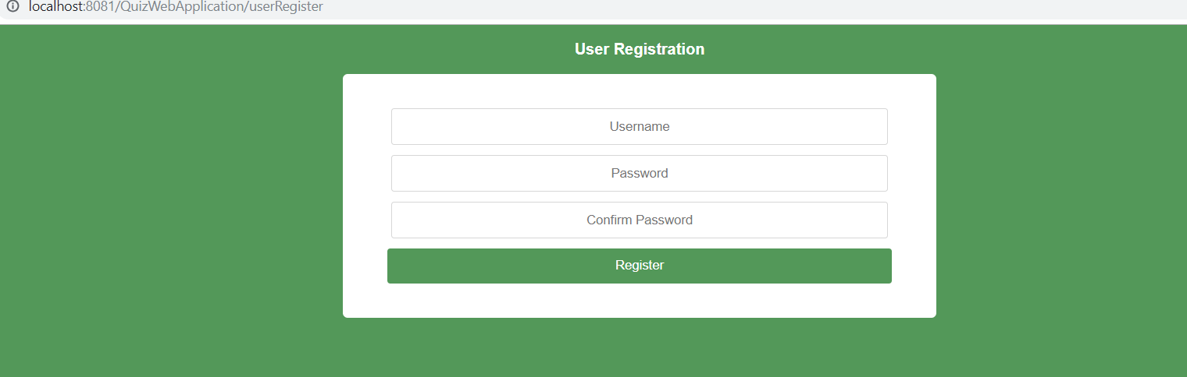

**Ushasri**

Advanced Java EPITA

1. User Logins to Quiz Application to answer Questions.

Here User id is Usha

Password is 123456.

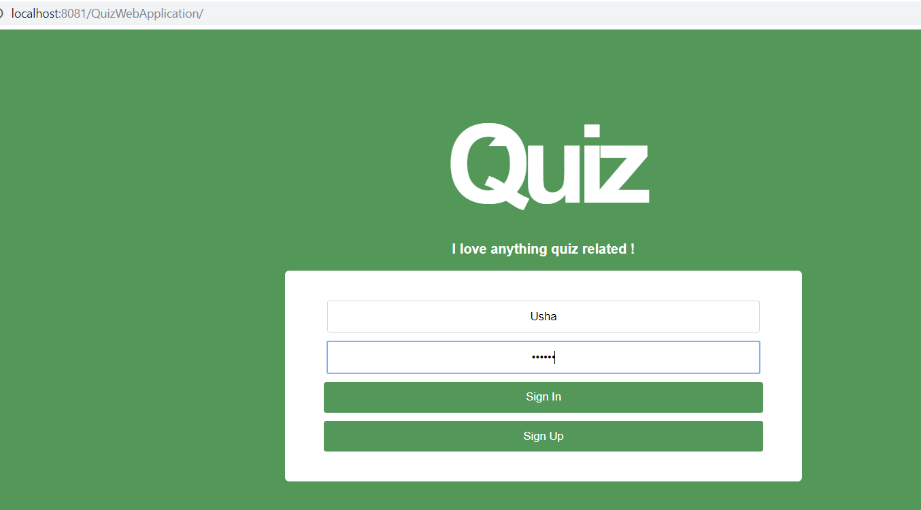

Home Page:

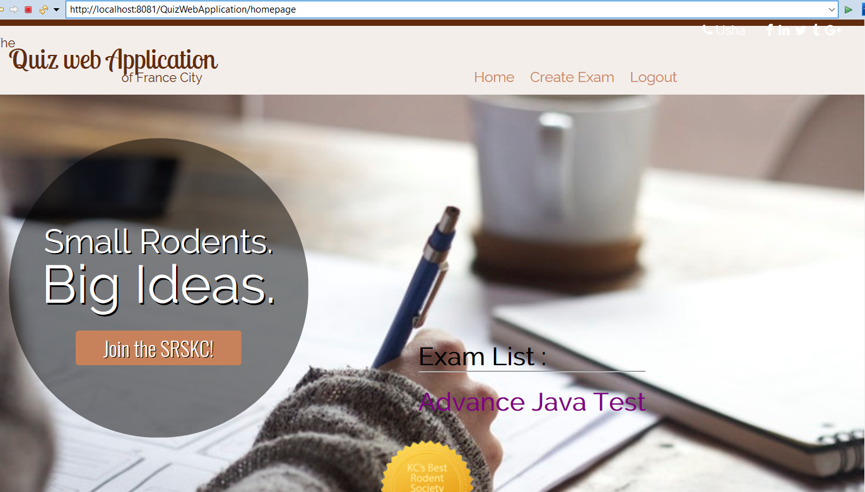

**Ushasri**

Advanced Java EPITA

1. Use can write both MCQ and Open questions.

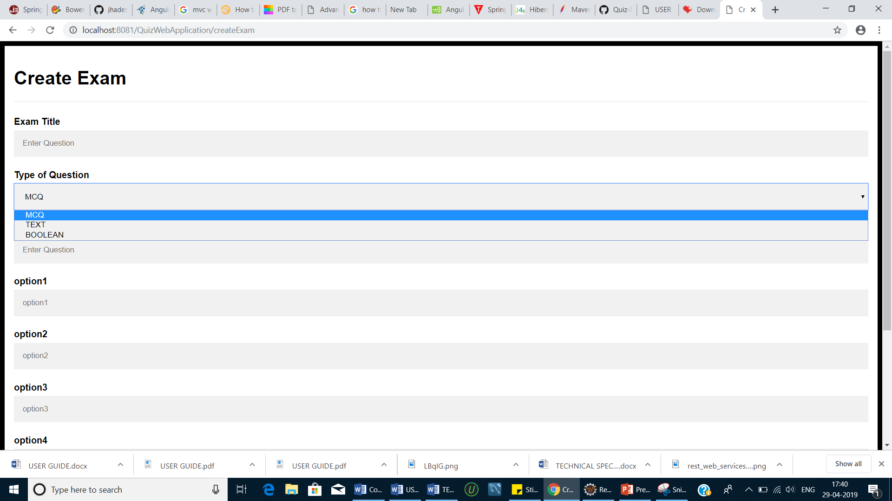

1. After user login to Quiz App, it displays questions with options. The user can select any one of the four options.

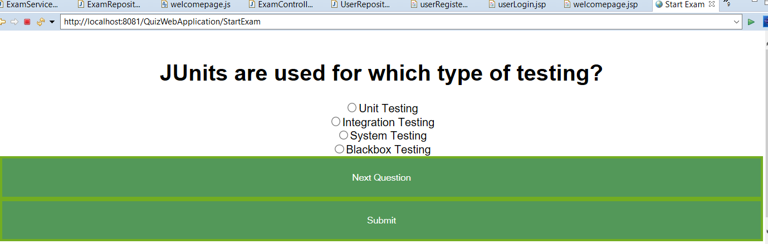

**Ushasri**

Advanced Java EPITA

7.Creating Exam:

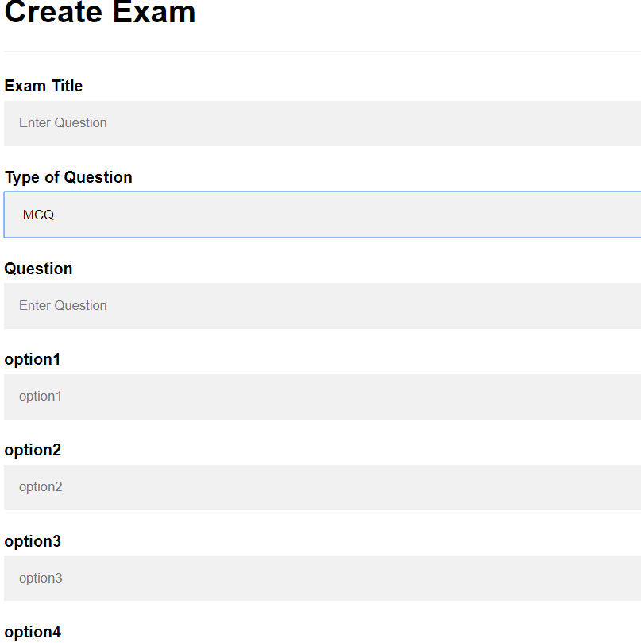

8.

<http://localhost:8081/QuizWebApplication/StartExam> starts exam

if questions over means as shown below dialogue box

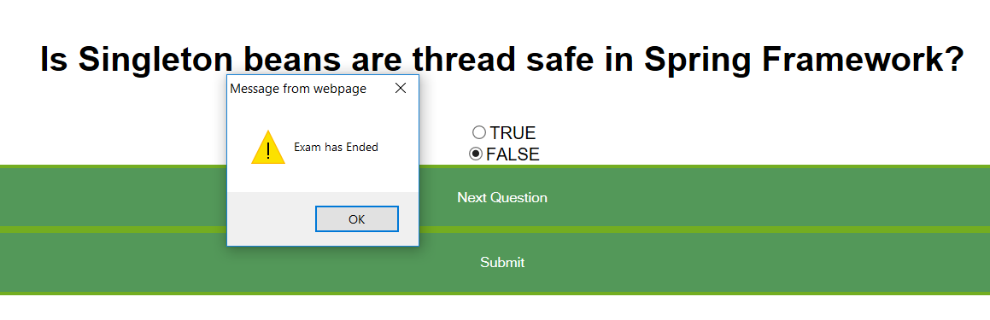

**Ushasri**

9.After Submit:

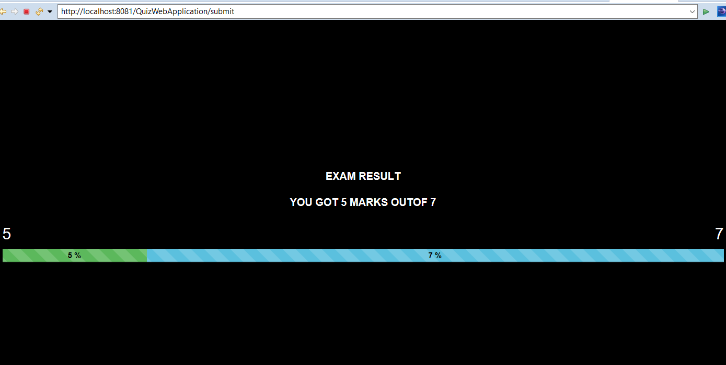

Ushasri